**Experiment-6**

* **Aim :**

Write a program to perform Support Vector Machine Classification.

* **Description :**

The goal of the SVM algorithm is to create the best line or decision boundary that can segregate n-dimensional space into classes so that we can easily put the new data point in the correct category in the future. This best decision boundary is called a hyperplane. SVM chooses the extreme points/vectors that help in creating the hyperplane. These extreme cases are called as support vectors, and hence algorithm is termed as Support Vector Machine.

* **Steps :**

1. Open the Weka GUI Chooser.

2. Click the “Explorer” button to open the Weka Explorer.

3. Load the dataset from the downloads/ionosphere.csv file.

4. Click “Classify” to open the Classify tab.

5. Select functions and select the LibSVM classifier for implementing SVM.

* **Output :**

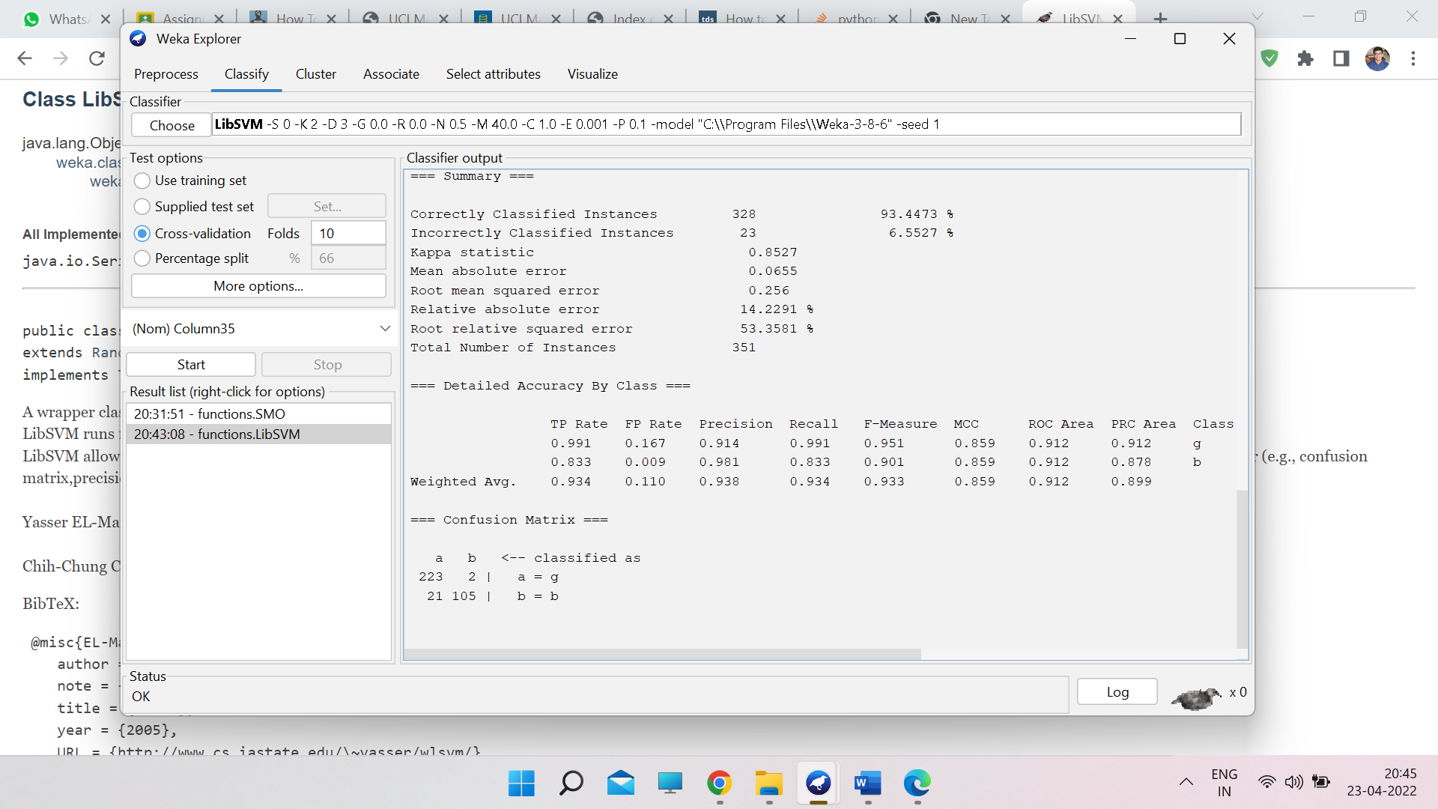

**Experiment-28**

* **Aim :**

Write a LISP program containing two functions: one to read input values and one to display them.

* **Description :**

In LISP, we can read input from STDIN using ‘read’ and output values into STDOUT using ‘write’. This has been demonstrated in the following program which calculates the area of a circle by taking radius value from STDIN.

* **Program :**

; the function AreaOfCircle

; calculates area of a circle

; when the radius is input from keyboard

(defun AreaOfCircle()

(terpri)

(princ "Enter Radius: ")

(setq radius (read))

(setq area (* 3.1416 radius radius))

(princ "Area: ")

(write area))

(AreaOfCircle)

* **Output :**

